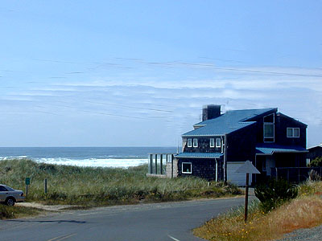
Camp Magruder

(Rockaway Beach)

All Youth Beach Retreat

November 1-3, 2024

When: Meet at Southminster Presbyterian Church at 4:00 p.m. Friday, Nov. 1st.
We expect to leave the church by 4:15p.m. and return home by 1:00 p.m. on November 3rd.

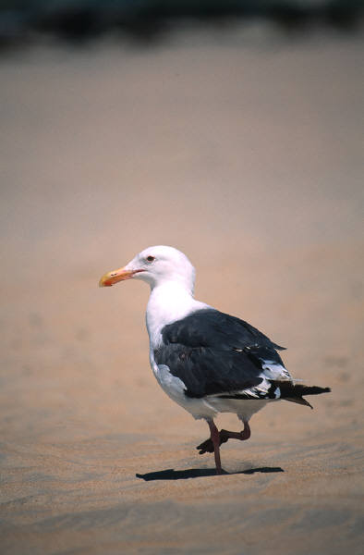
Cost: $50.00 (scholarships available)
What to Expect?
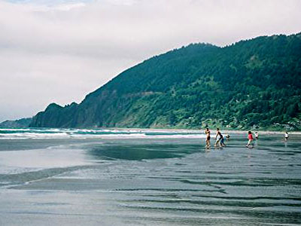
A crazy get-away filled with relaxing activities, hanging out, a campfire on the beach, visit to the Tillamook Cheese Factory, thoughtful discussions and much more. Friends are Welcome@

What to Bring:
Sleeping Bag & pillow, bathroom supplies, warm clothing, swimsuit & towel, flashlight, personal money for shopping…..

Any Questions: Contact Don Ludwig, 503-819-2442
 - - - - - - - - - - - - - - - - - - - - - - - - - - - - - - - - - - - - - - - - - - - - - - - - - - -


Permission Form for All Youth Beach Retreat ~ Nov. 1-3, 2024 ~

I give permission for _______________________________________________ to attend the All Youth retreat at Camp Magruder on Nov. 1-3 with Southminster Presbyterian Church. In case of an emergency, I grant permission for Youth Leaders to administer necessary health & safety measures.

Date__________________ Parent’s Signature ___________________________________

Contact Information (cell phone) _____________________________________

_____Yes, a medical form is on file.
_____No, a medical form is not on file, and I will need to fill one out.
_____I give permission for pictures to be sparingly used on social media (facebook).

